9.25: a) 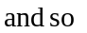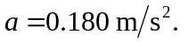
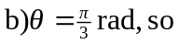

The tangential acceleration is still 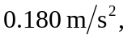and so on
c) is still